Intermediate metrics calculation
This query helps to derives three key performance metrics per channel: average order value (revenue ÷ orders), purchase frequency (orders ÷ customers), and historical CLTV (revenue ÷ customers). To ensure clean data output, all calculations are rounded to two decimal places and use NULLIF to safely prevent divide-by-zero errors.

QUERY-;

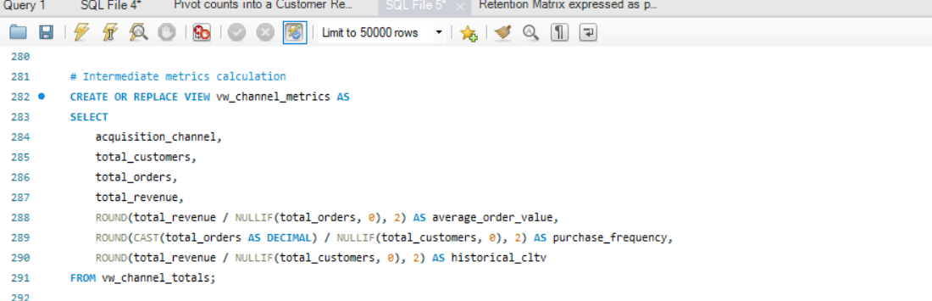

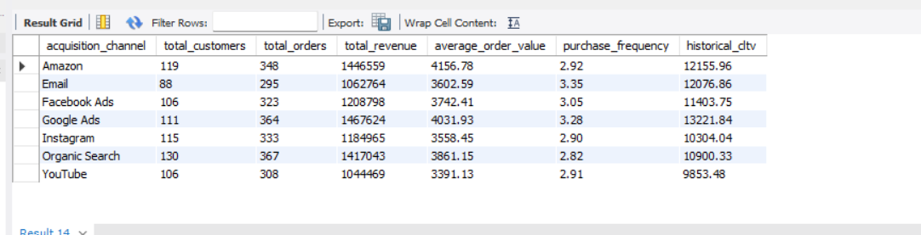
OUTPUT-;

